**CRYPCHAT- CRYPTIC MESSENGER**

Enrollment No. – 13103612

Name of Student – Karan Singla



**May – 2017**

Submitted in Partial fulfillment of the Degree of

Bachelor of Technology

In

Computer Science and Engineering

DEPARTMENT OF COMPUTER SCIENCE ENGINEERING & INFORMATION TECHNOLOGY

JAYPEE INSTITUTE OF INFORMATION TECHNOLOGY, NOIDA

**TABLE OF CONTENTS**

**Chapter No. Topics Page No.**

Student Declaration 4

Certificate from the Supervisor 5

Acknowledgement 6

Summary 7

List of Figures 8

List of Tables 8

**Chapter-1 Introduction** 9-13

* 1. General Introduction
  2. Problem statement
  3. Approach to problem in terms of technology/platform to be used
  4. Software development process used for implementation
  5. Support for novelty/significance of the problem

**Chapter 2 Functionality** 14-22

**Chapter 3: Analysis, Design and Modelling**  23-35

3.1 Overall Description

3.2 Non Functional requirements

3.3 Overall architecture with component description and dependency details

3.4 Design Documentation

3.4.1 Database overview

3.4.2 Description of tables

3.4.3 Use Case diagram

3.4.4 Activity diagram

3.4.5 Sequence diagram

3.4.6 Class diagram

3.4.7 Algorithms used

**Chapter-4 Implementation details** 36-42

4.1 Login and signup

4.2 Sent message

4.3 Other functionalities

**Chapter-5 Testing and Result**

5.1 Component decomposition and type of testing required

5.2 Data annotations in sign in and signup form

5.3 Check for wrong credentials

5.4 Data annotations in conversation and edit profile for admin

5.5 Check in change password

5.6 Check if encryption is selected before sending message

5.7 Not allowing user to log in which are blocked

5.8 Encrypted and decrypted message

5.9 Option of forget password for user

5.10 Unit test plan

5.11 Integration test plan

**Chapter-6 Findings and Conclusion** 43

6.1 Conclusion

6.2 Future work

**DECLARATION**

I hereby declare that this submission is my own work and that, to the best of my best knowledge and belief, it contains no material previously published or written by another person nor material which has been accepted for award of any other degree or diploma of the university or other institute of higher learning, except where due acknowledgement has been made in the text.

Place: JIIT, Noida Signature:

Date: May 30, 2017 Name: Karan Singla

Enrolment No. – 13103612

**CERTIFICATE**

This is to certify that the work titled “CrypChat-Cryptic Messenger” submitted by

Karan Singla (13103612) in partial fulfillment for the award of degree of B. Tech of Jaypee Institute of Information Technology, Noida has been carried out under my supervision. This work has not been submitted to any other University or Institute for the award of this or any other degree or diploma.

Signature of Supervisor

Name of Supervisor: Ms. Neha Thakur

Designation: ETA MS-Track

**ACKNOWLEDGEMENT**

We express our deep sense of gratitude to our respected and learned guide Ms. Neha Thakur for her valuable help and guidance, we are thankful to her for the encouragement she had given us in completing the project.

We are also thankful to all the other faculty & staff members of our Department for their kind co-operation and help.

Lastly, we would like to express our deep apperception towards our classmates and or indebtness to our parents for providing us the moral support and encouragement.

Signature of the Student:

Name: Karan Singla

Enrolment No. 13103612

Date: May 30, 2017

**SUMMARY**

This project is helpful for increasing knowledge of students in encryption technologies, front end development and back end development. CrypChat is a chat messenger which allows users to chat with each other.

The main focus of this project is the encryption feature of messages which is available to users. A user can choose one of the encryption technologies available and encrypt his/her message before sending to other user, this ensures that the data transferred will be safe from third party access.

The project has been made user-friendly. A user can send messages to a particular user, broadcast messages, report other users for block purposes, edit his/her profile details, search other users, etc.

__________________ __________________

Signature of Student Signature of Supervisor

Name: Karan Singla Name: Ms. Neha Thakur

Date: May 30, 2017

**LIST OF FIGURES**

|  |  |  |
| --- | --- | --- |
| **S. No.** | **Description** | **Page No.** |
| 1 | Use case diagram | 30 |
| 2 | Activity diagram | 31 |
| 3 | Sequence diagram | 32-33 |
| 4 | Class diagram | 34 |

**LIST OF TABLES**

|  |  |  |  |  |
| --- | --- | --- | --- | --- |
| **S. No.** | **Name of Tables** | **Description** | | **Page No.** |
| **1** | Role | Store the user/admin role id | 27 | |
| **2** | User | Store register user and admin information | 27 | |
| **3** | Encryption | Store available encryption technique | 28 | |
| **4** | Block | Store those users which are blocked | 28 | |
| **5** | Conversations | Store all messages with sender and receiver id | 29 | |

**CHAPTER – 1**

**Introduction**

* 1. General Introduction

Encryption is the process in which we encode a simple text message into a complex form so that only the authorized user can view the messages. It helps in keeping the data secure as in today’s world data is very important.

There are a lot of ways in which data can be encrypted. Some of them are:

* Caesar cipher
* RSA
* Playfair cipher
* Transposition
* XOR Cipher

A messenger which allows its users to send messages to a common intermediate server in an encrypted form, from where the receiver can pick up his message and decrypt it accordingly. The encryption can be done in a variety of cipher techniques like play fair, Caesar, vigenere etc. The choice of encryption techniques depends on the sender.

Cryptic messenger provides an important feature of encryption to its users. The users can chat with their friends in a way that their conversations are secure and cannot be read by any unauthorized person. The users can also report unwanted users who will later get blocked by the admin. The users can also update their details later at any point of time. The cryptic messenger uses a simple and user-friendly user interface.

* 1. Problem Statement

Today a large percentage of population communicate with each other through online chat rooms, messengers etc. A major issue during communicating is that any third person may be able to read the important information which is not good. So in this project we have on worked on a problem of making a chat messenger for users to communicate with each other by encrypting the data before sending to other user, this ensures that data is read only by the authorized person.

Thus we have on worked on chat messenger which has various available techniques for users to select from before sending the data to the other user. When the user on the other side receivers the encrypted message, he/she can click on the encrypted message to decrypt the message and read it.

* 1. Approach to problem in terms of technology/platform to be used

The project has been implemented on Microsoft visual studio. A chat messenger has been implemented using C# language for backend processing, html, css, bootstrap, ajax has been used for front end implementation and sql server management studio for database management.

Various encryption algorithms have been included in the project for data encryption. Some of the algorithms are Caesar cipher, Vigenere Cipher, RSA etc.

The whole project has been implanted on .Net framework 4.5.

1.4 Software Development Process used for implementation

The process which was used in the development process was Agile Software Development Process. It describes a set of principles for software development under which requirements and solutions evolve through the collaborative effort of self-organizing cross-functional teams. It advocates adaptive planning, evolutionary development, early delivery, and continuous improvement, and it encourages rapid and flexible response to change. These principles support the definition and continuing evolution of many software development methods.

The whole project implementation was divided into 16 User Stories cumulatively. The user stories were implemented in 3 sprints having 10 days each. The burn down chart for each sprint is as follows:

**Sprint 1 Burn Down Chart:**

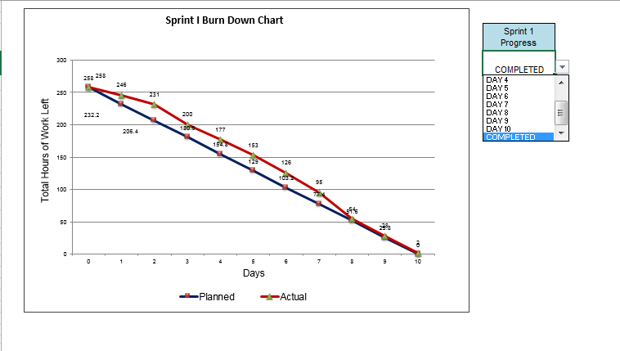

**Sprint 2 Burn Down Chart:**

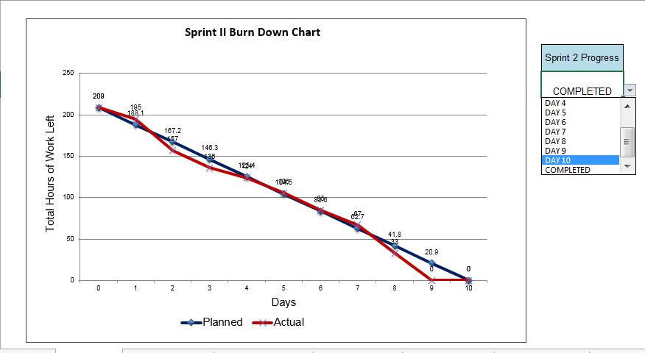

**Sprint 3 Burn Down Chart:**

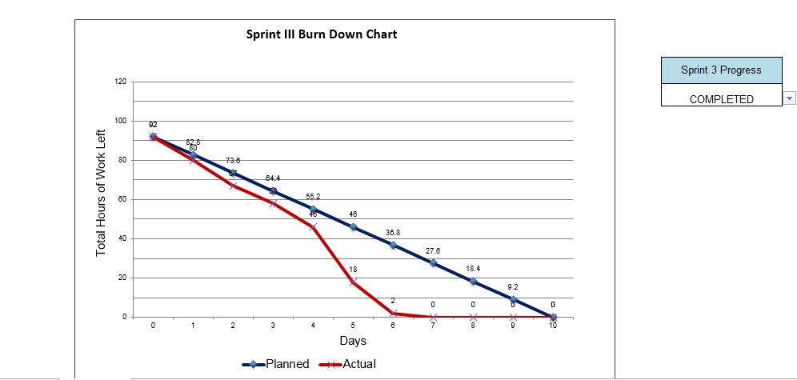

1.5 Support for Novelty/significance of problem**:**

In this project, we have worked on chat messenger which allows users to encrypt messages before sending them to other users. The user on the other side can decrypt the message when he/she wants to read the message.

**Chapter-2**

**Functionalities**

User logs in in the CrypChat messenger:

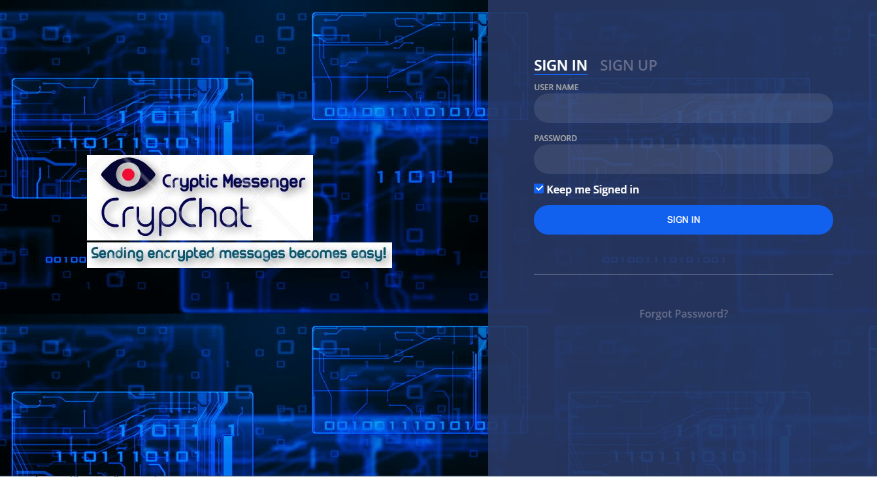

Sign up of new user:

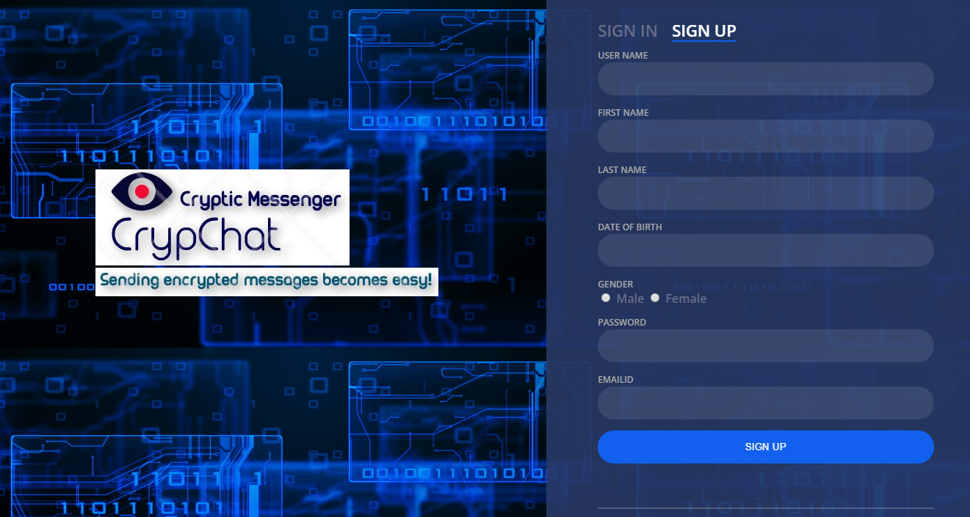

Home page for admin in which admin can search a particular user, enable/disable a user and send a mail to a user:

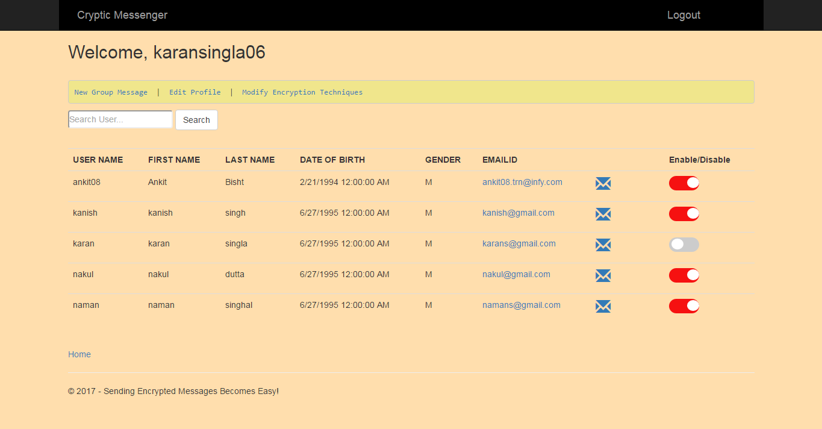

Admin can broadcast messages:

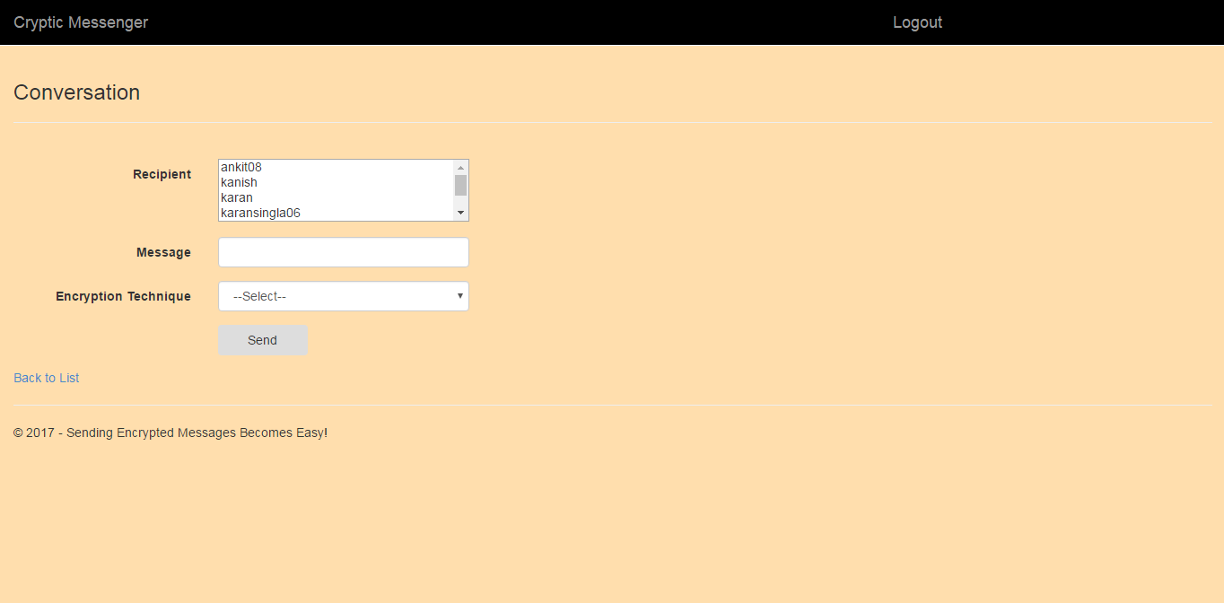

Edit profile for admin:

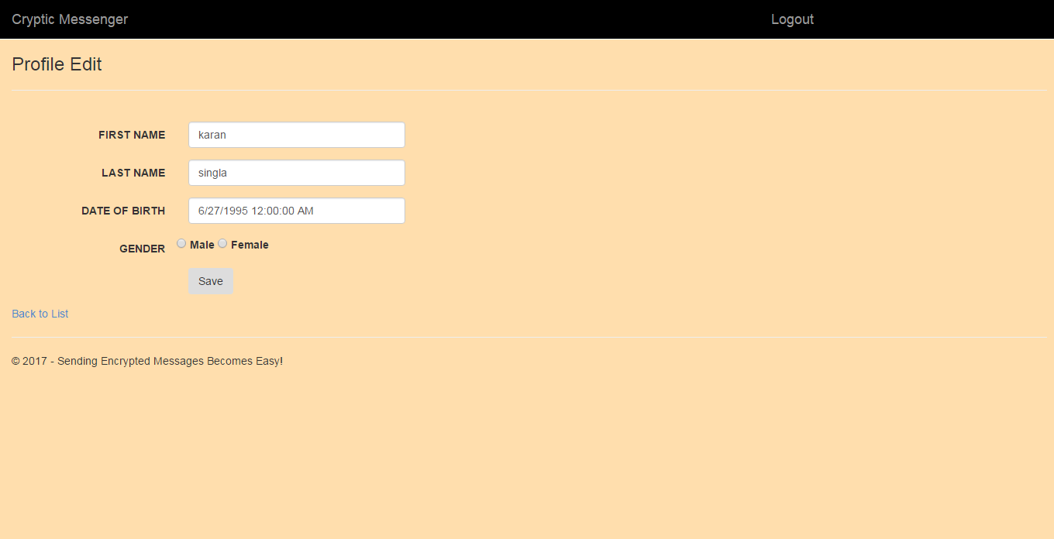

Admin can restrict encryption techniques which are available to user:

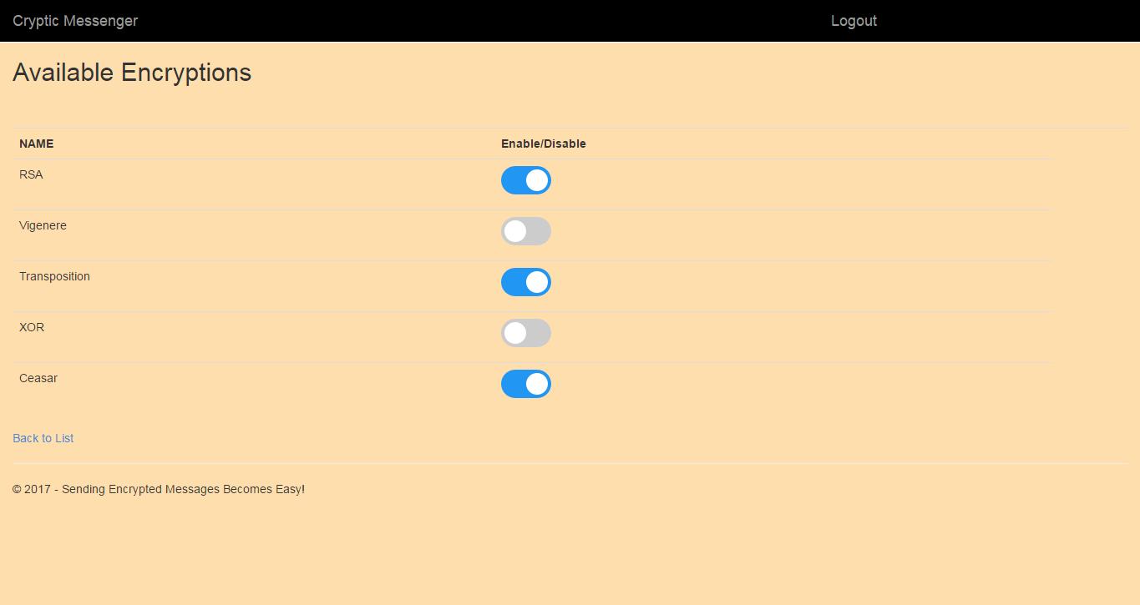

Home page for user:

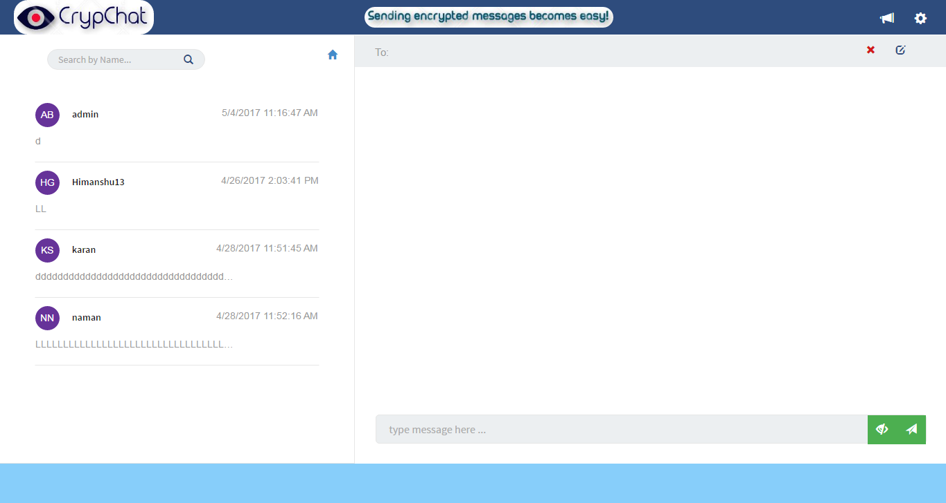

Selecting a particular user for chatting:

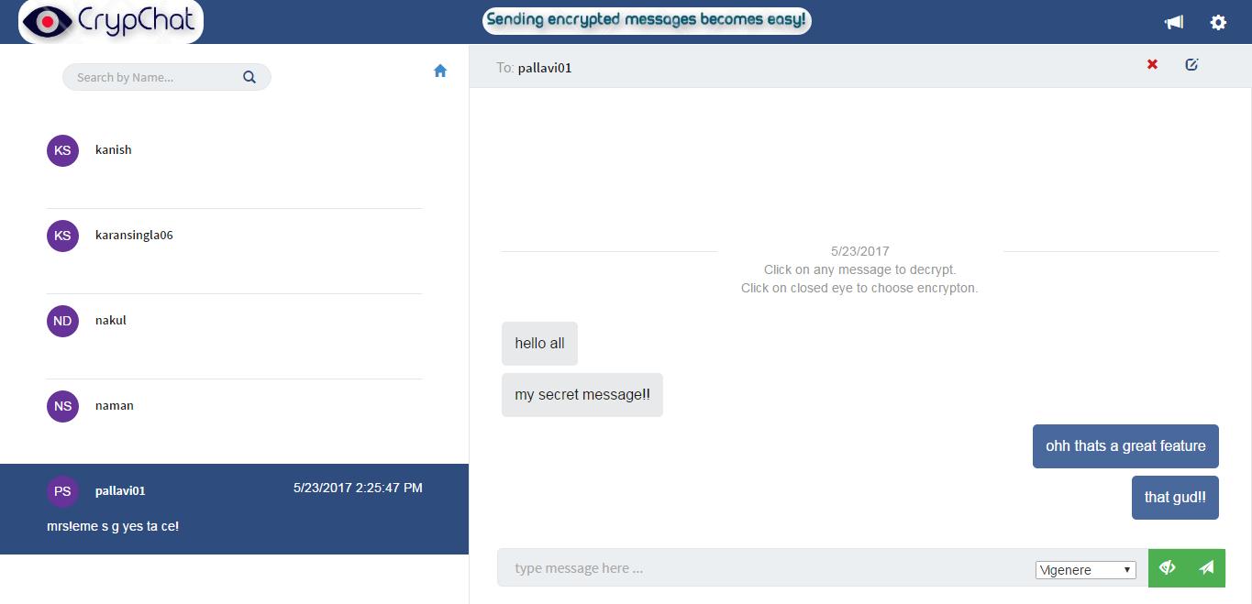

Sending encrypted messages:

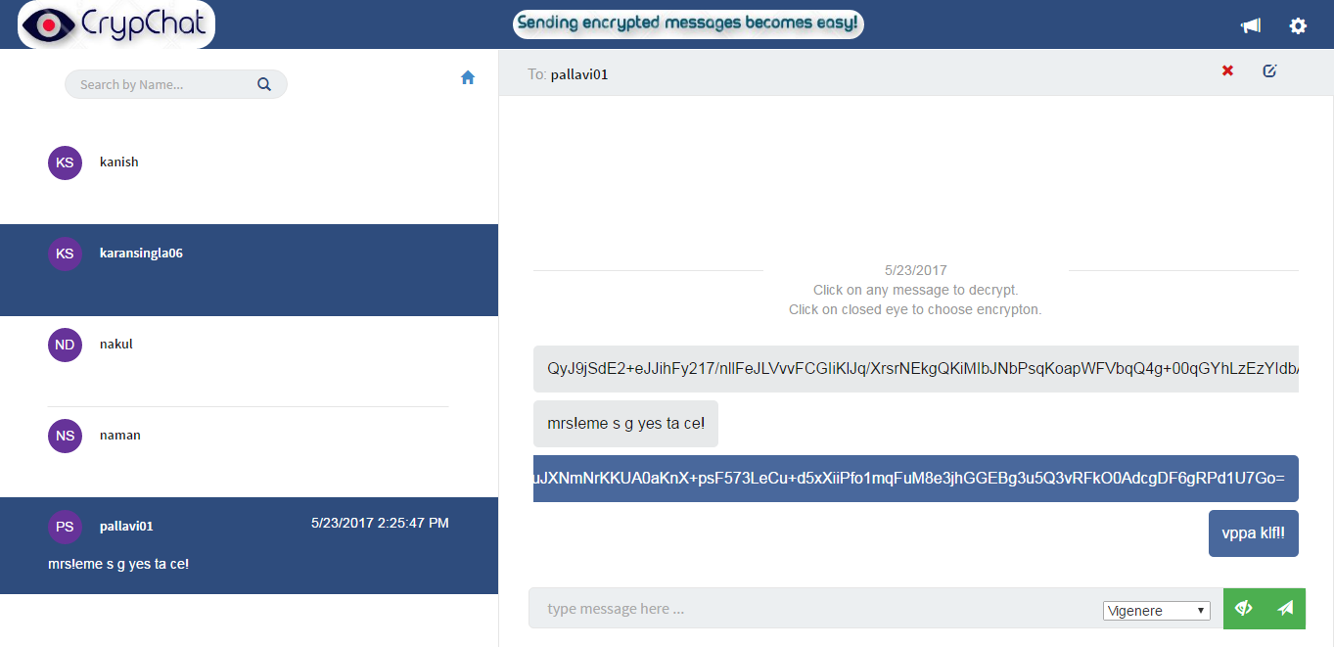

User can broadcast message:

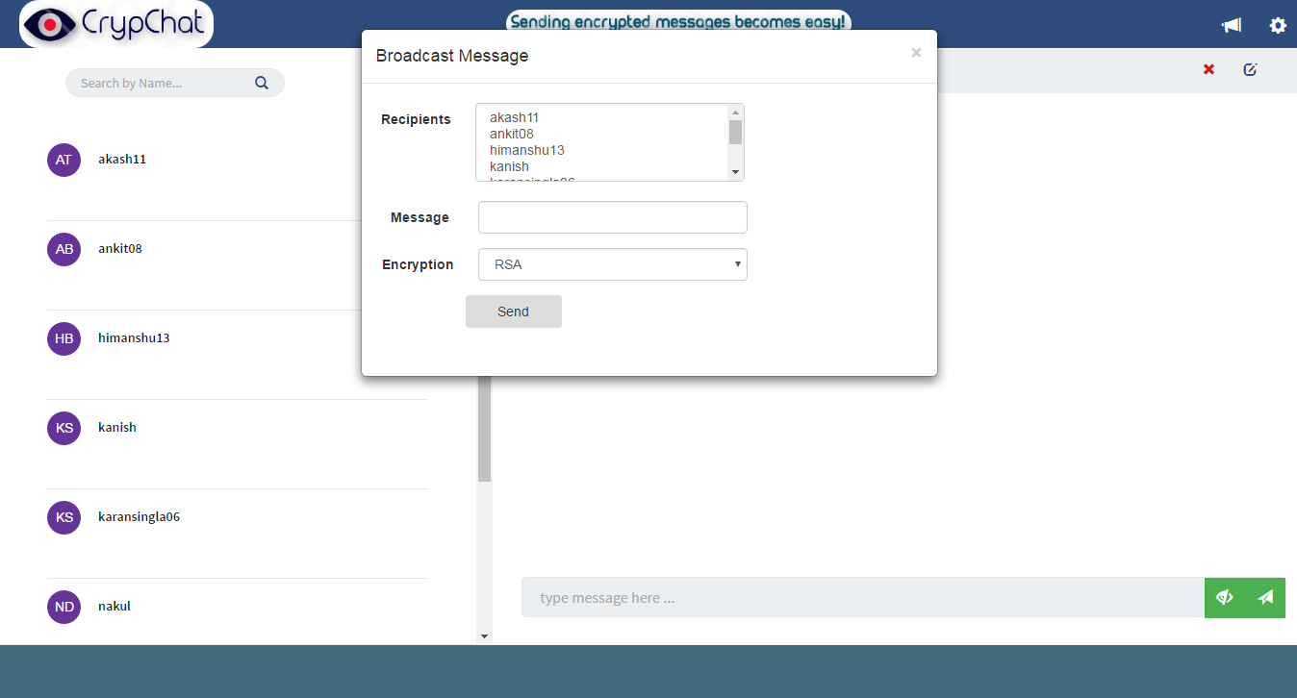

User can report another user:

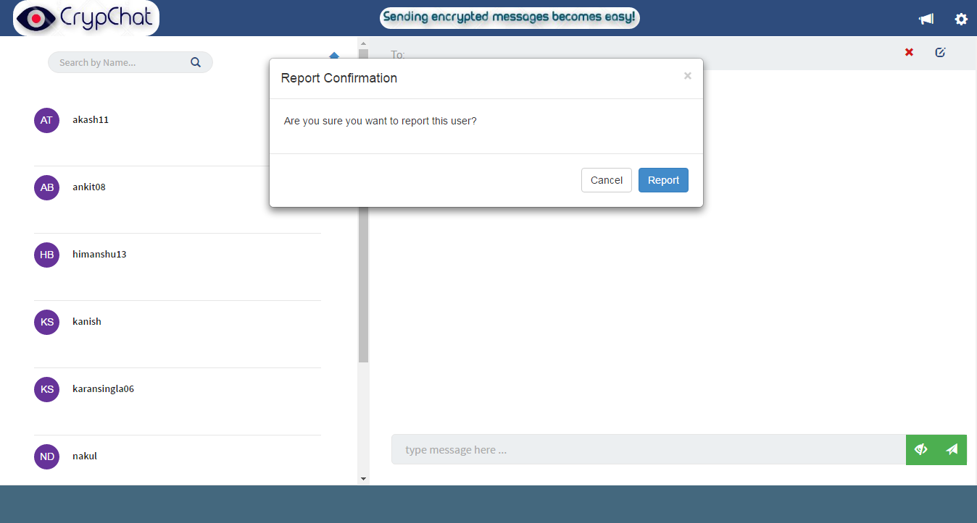

User can edit profile:

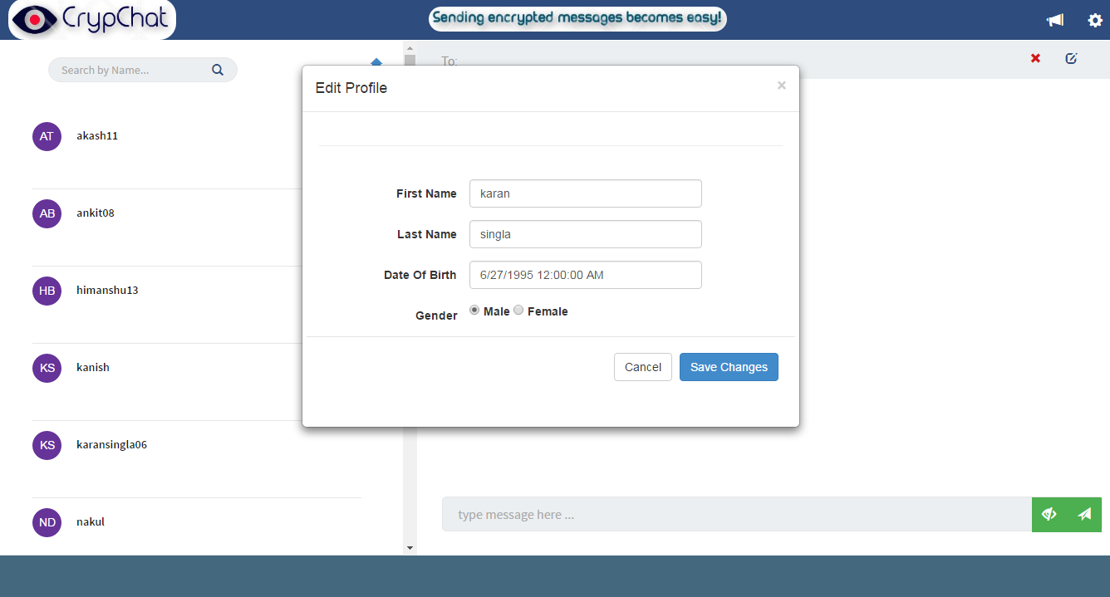

User can change password:

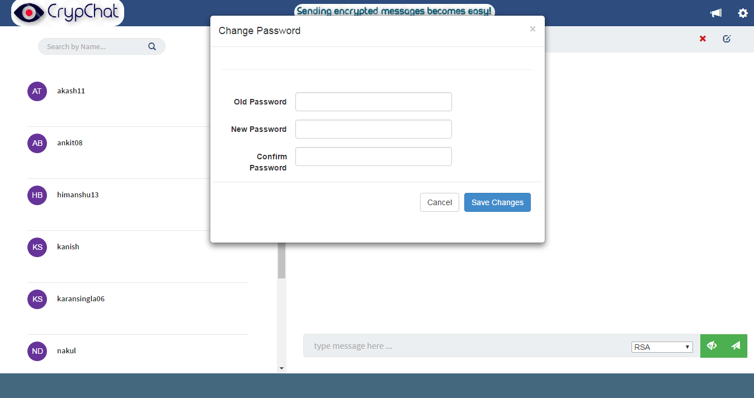

User can deactivate account:

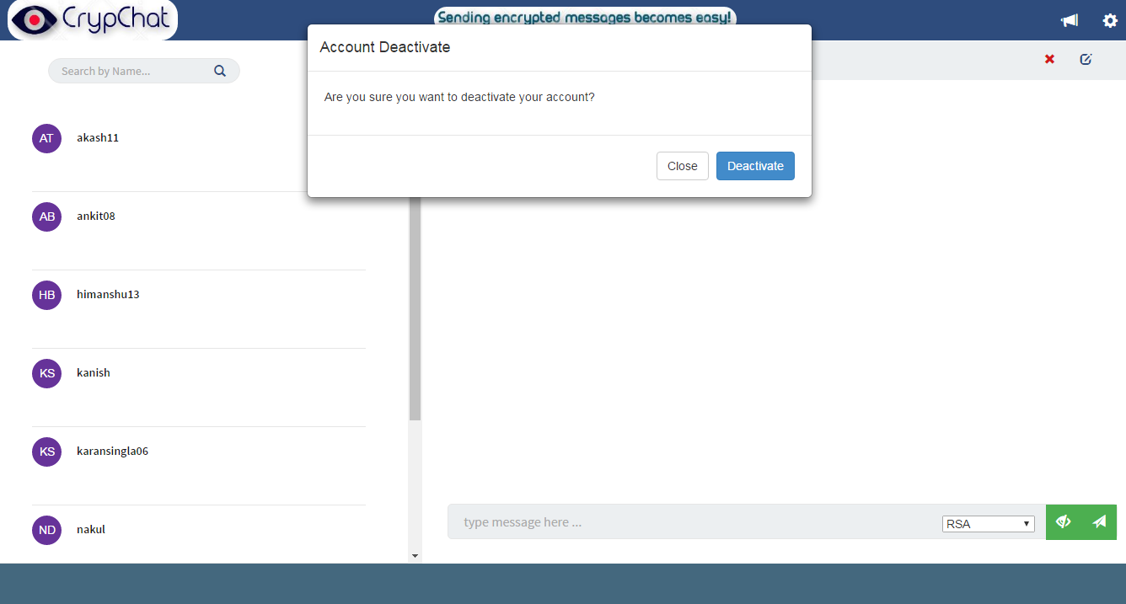

User can reactivate the account after deactivation in the following manner:

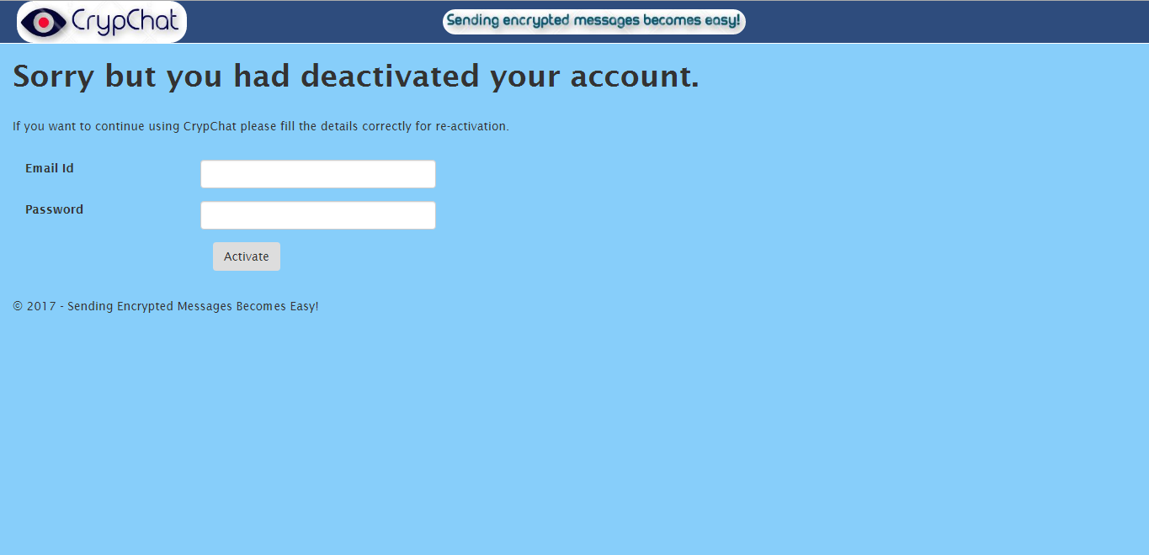

Details of CrypChat messenger:

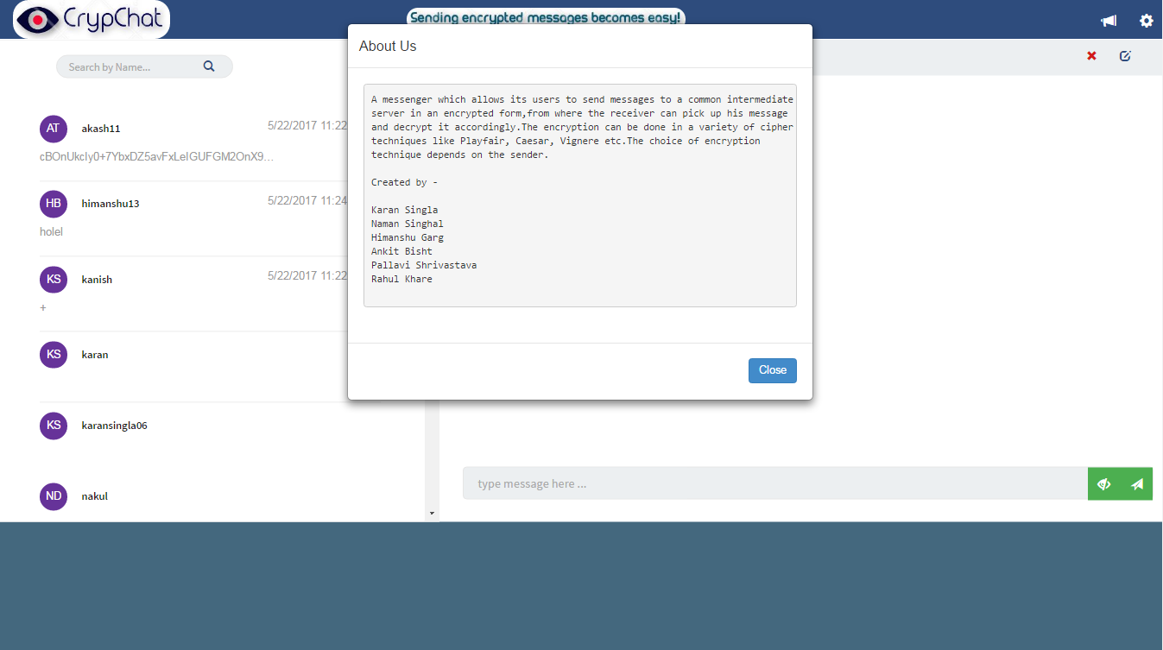

Forgot password for user:

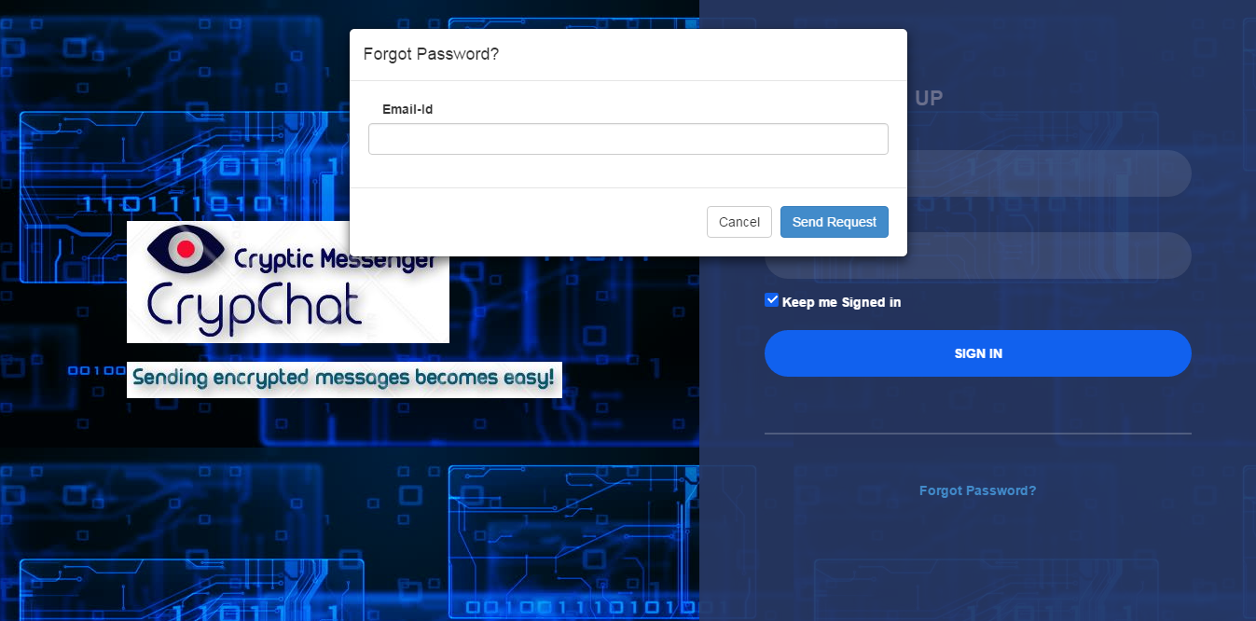

**Chapter-3**

**Analysis, Design and Modelling**

* 1. OverallDescription

3.1.1ProductPerspective

3.1.1.1 System Interfaces

The application requires database connectivity with Visual Studio. The application runs on local host and hence does not need any internet connectivity.

3.1.1.2 Hardware requirement

1. CPU: 500 MHz processor
2. Computer Processor: Intel i5 or Intel i3 core
3. Computer Memory: 500Mb or more
4. Network: Internet Connection Required for Map

3.1.1.3 Software Requirement

1. Operating system: windows 7/10 , Macintosh version 8 and onwards
2. Visual Studio
3. SQL Server Management Studio
4. Software: Mozilla Firefox or Google Chrome

3.1.2 Product functions

3.1.2.1 User:

1. User can sign up as well as login his/her account and send messages.

2. User can send messages and select any of the encryption techniques available

according to his/her choice.

3. User can send messages to multiple users by broadcasting the messages.

4; User can edit his/her profile details.

5. User can deactivate his/her account.

3.1.2.2 Admin:

1. Admin can login his/her account.

2. Admin can broadcast messages to multiple users.

3. Admin can enable/disable any particular user.

4. Admin can edit his/her profile details.

5. Admin can enable/disable encryption techniques.

6. Admin can send an email to any user.

3.2 Non Functional requirements

3.2.1Efficiency of the tool  
Efficiency of the system is the main concern. It may be defined as to how accurately the data is processed by the system

3.2.2ReliabilityThe system deals with large data and therefore try to make it less prone to failures.

3.2.3 Portability  
The system must be usable in different environments like Linux, windows etc.

3.2.4 Usability  
The system must be user friendly, easy to learn, satisfying to use and fast.

3.2.5 Performance  
The system must offer high accuracy, fast processing and high throughput

3.2.6SecuritySystem must be safe from external hacks and data thefts.

3.3 Overall architecture with component description and dependency details

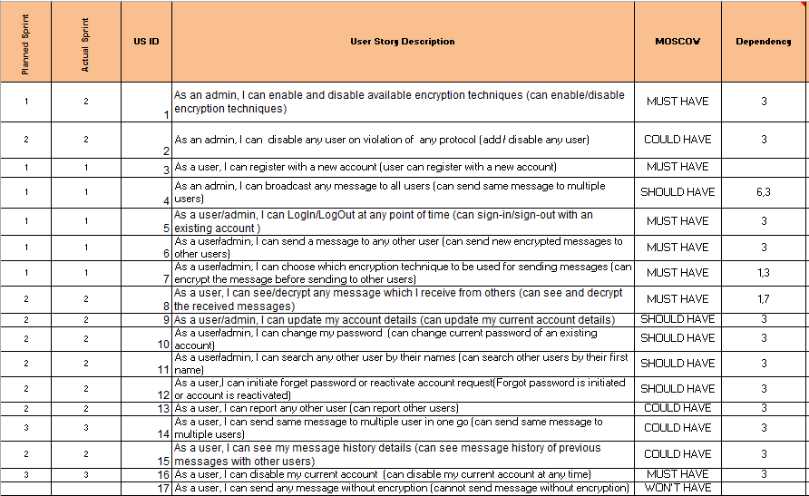

3.4 Design Documentation

3.4.1 Database overview

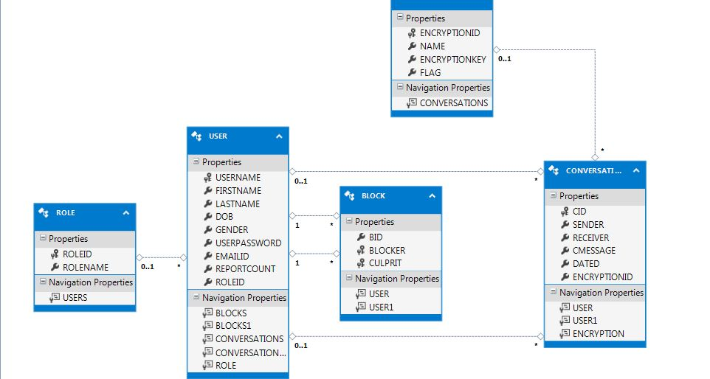

3.4.2 Description of tables

Role

|  |  |  |  |  |  |
| --- | --- | --- | --- | --- | --- |
| No. | Field Name | Description | Size | Type | Optional/  Mandatory |
| 1. | RoleId | Id of the role |  | INT | Mandatory |
| 2. | RoleName | Describes the role(whether user or admin) | 30 | Varchar | Mandatory |

User

|  |  |  |  |  |  |  |
| --- | --- | --- | --- | --- | --- | --- |
| No. | Field Name | Description | Size | Type | Optional/  Mandatory | Default Values |
| 1. | UserName | The name user wants to get displayed to other users | 30 | Varchar | Mandatory |  |
| 2. | FirsrtName | The first name of the user | 30 | Varchar | Mandatory |  |
| 3. | LastName | The last name of the user | 30 | Varchar | Optional |  |
| 4. | DOB | Date of birth of the user |  | Date | Mandatory |  |
| 5. | Gender | Gender of the user can be M or F | 2 | Char | Mandatory |  |
| 6. | UserPassword | Password for login | 15 | Varchar | Mandatory |  |
| 7. | EmailId | EmailId of the user | 50 | Varchar | Mandatory |  |
| 8. | ReportCount | The number of users who have reported this user to get it blocked |  | Int |  | 0 |
| 9. | RoleId | RoleId referring to the Roles table |  | Int |  | 2 |

Encryption

|  |  |  |  |  |  |  |
| --- | --- | --- | --- | --- | --- | --- |
| No. | Field Name | Description | Size | Type | Optional/  Mandatory | Default values |
| 1. | EncryptionId | Uniquely identifies the encryption technique |  | Int | Mandatory |  |
| 2. | Name | Name of the encryption technique | 30 | Varchar | Mandatory |  |
| 3. | EncryptionKey | Key to be used for the corresponding technique | Max | Varchar | Mandatory |  |
| 4. | Flag | Flag variable to enable/disable encryption |  | Int | Mandatory | 1 |

Block

|  |  |  |  |  |  |  |
| --- | --- | --- | --- | --- | --- | --- |
| No. | Field Name | Description | Size | Type | Optional/  Mandatory | Default values |
| 1. | BId | Uniquely identifies the blocker |  | Int | Mandatory |  |
| 2. | Blocker | Refers to a user in the user table to wants to block | 30 | Varchar | Mandatory |  |
| 3. | Culprit | Refers to a user in user table who has to be blocked | 30 | Varchar | Mandatory |  |

Conversations

|  |  |  |  |  |  |  |
| --- | --- | --- | --- | --- | --- | --- |
| No. | Field Name | Description | Size | Type | Optional/  Mandatory | Default values |
| 1. | Cid | Uniquely identifies a conversation |  | Int | Mandatory |  |
| 2. | Sender | Refers to a user in users table who sends a message | 30 | Varchar | Mandatory |  |
| 3. | Receiver | Refers to a user in users table who receives a message | 30 | Varchar | Mandatory |  |
| 4. | CMessage | Message to be sent | Max | Varchar | Mandatory |  |
| 5. | Dated | Date on which message is sent |  | Date | Optional | System date |
| 6. | EncryptionId | Refers to the encryption id in the encryptions table |  | Int | Optional |  |

**3.4.3 Use Case Diagram**

Add/Remove encryption technique

Add/Remove user

Broadcast message

Admin

Register

Login/Logout

Choose encryption technique

Send message

Update account

Change password

Report other user

User

Search other user

Delete current account

View history

**3.4.4 Activity Diagram**

No Register

Start

Existing user

Yes

Login

Report

Select encryption technique

Update profile Send message Logout Change password

End

**3.4.5 Sequence Diagram**

User User Interface Repository Database

Register Data verification Store verified data

Successful registration message

Login Input Login details Verification of login details

Chat box (Success)/Login (Failure) Success/Failure

Select receiver &

encryption technique

Return receiver & encryption technique

Write message Message stored and sent

Message history shown

Report user Stored and report count increased

Success message

Admin User Interface Repository Database

Login Input Login details Verification of login details

Users List (Success)/Login (Failure) Success/Failure

Select multiple Users and

encryption technique

Return selected users and technique

Write message Message stored and sent

Success

Select user to be blocked Check if report count is >=3

Disable user

Select Encryption Technique

to Enable/ Disable

Successfully enabled/disabled

**3.4.6 Class Diagram**

USER BLOCK

ROLES UserName BID

RoleId FirstName Blocker

RoleName Has LastName Culprit

DOB

Gender

UserPassword

EmailId

ReportCount

RoleId CONVERSATION

Add Cid

Update Sender

Report/ Receiver

Block CMessage

Dated

EncryptionId

ENCRYPTION Uses

EncrytpionId

Name

EncryptionKey

Flag

Enable

Disable

**Session Management Techniques**

The session management techniques used in Crypchat are:

Session:

In order to implement any session of a user or admin for the time he is logged in session variables have been used. Until the user or admin logs out from his account his information will be stored and he can use all the functionalities of CrypChat. By default, ASP.NET session state is enabled for all ASP.NET applications.

3.4.7 Algorithms used

The algorithms used are:

1) Playfair cipher:

The Playfair cipher is a written code or symmetric encryption technique that was the first substitution cipher used for the encryption of data. It involves the use of keys that arrange alphabetical letters in geometric patterns in order to encode messages. The Playfair cipher is also known as the Playfair square.

2) Vigenere cipher:

The Vigenere cipher is a plain-text form of encoding that uses alphabetical substitution to encode text.

3) RSA:

RSA is an algorithm used by modern computers to encrypt and decrypt messages. It is an asymmetric cryptographic algorithm. Asymmetric means that there are two different keys. This is also called public key cryptography, because one of them can be given to everyone.

4) Transposition cipher:

A transposition cipher is a method of encryption by which the positions held by units of plaintext (which are commonly characters or groups of characters) are shifted according to a regular system, so that the ciphertext constitutes a permutation of the plaintext.

5) XOR Cipher:

XOR is a logical operation, pronounced exclusive or. It can be used to cipher messages simply and fast.

**Chapter-4**

**Implementation details**

4.1 **Login and Signup**

Any registered user/admin can login using its credentials.

4.2 **Sent Message**

User can send messages to other user using any available encryption technique provided by the admin. Admin can enable/disable those techniques from its portal.

4.3 **Other Functionalities**

User can report any other user. If a user is reported thrice he/she will be blocked by the system automatically. Admin can also disable any user account from its portal.

**Chapter-5**

**Testing and Result**

**5.1 Component decomposition and type of testing required**

For our project, we have used Unit Testing as every individual is assigned a task to be completed on his own.

**5.2 Data Annotations in sign in sign up form**

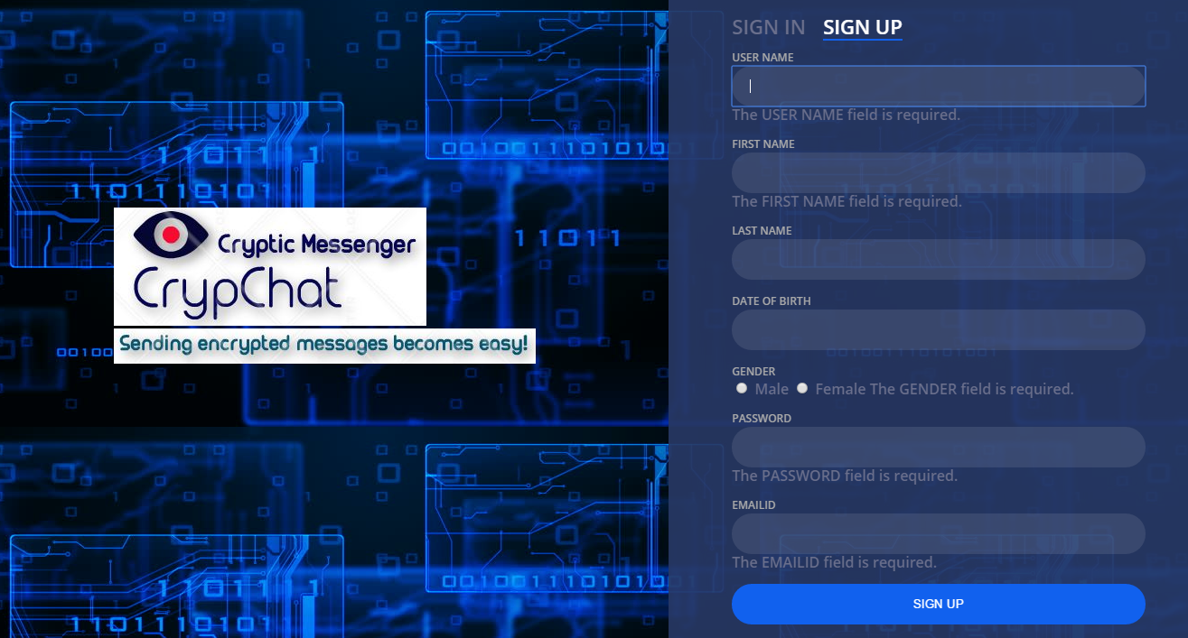

**5.3 Check for wrong credentials**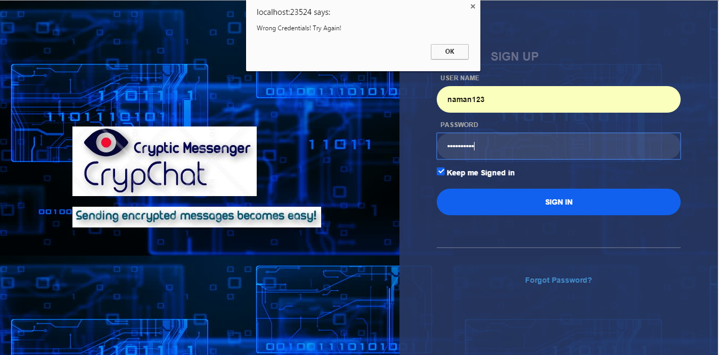

**5.4 Data Annotations in conversation and Edit Profile for Admin**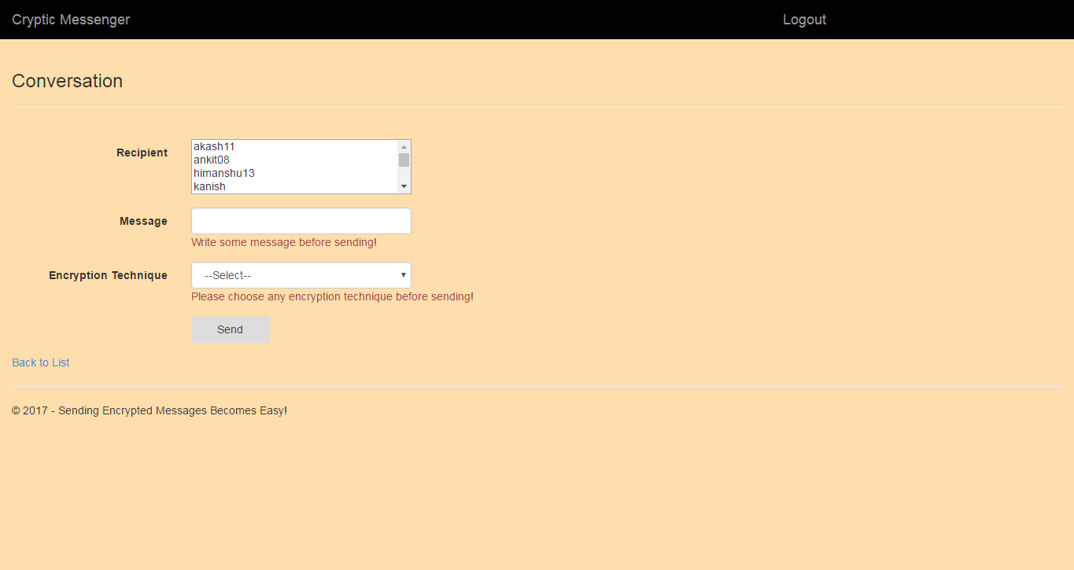

**5.5 Check in change password**

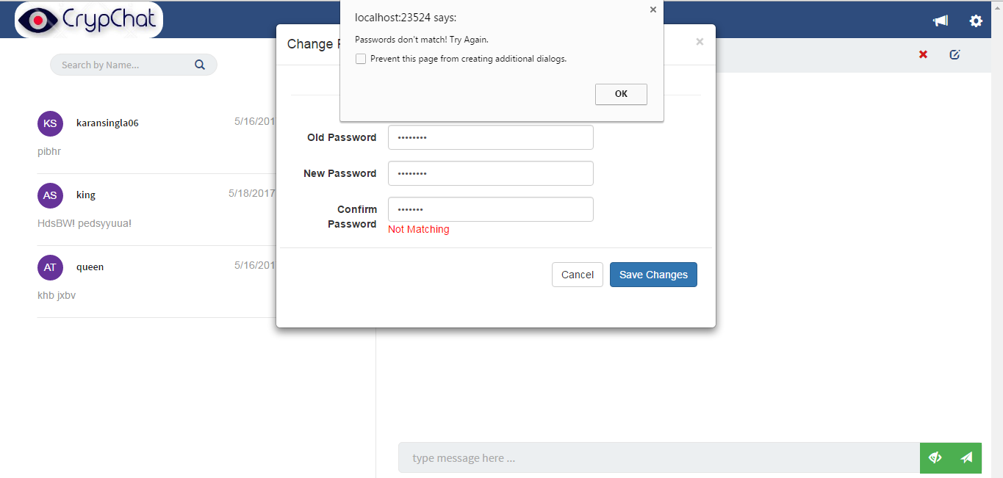

**5.6 Check if Encryption is selected before sending message**

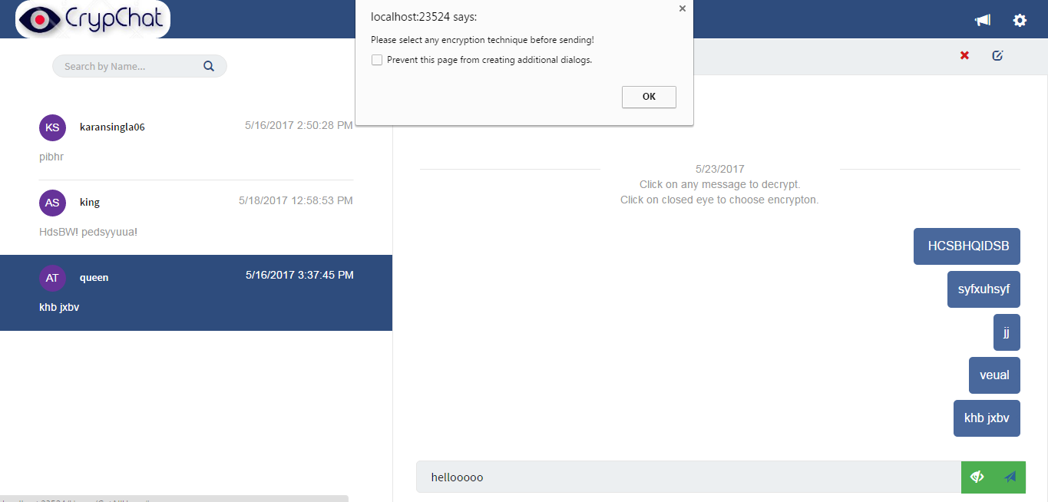

**5.7 Not allowing user to Login which are blocked** 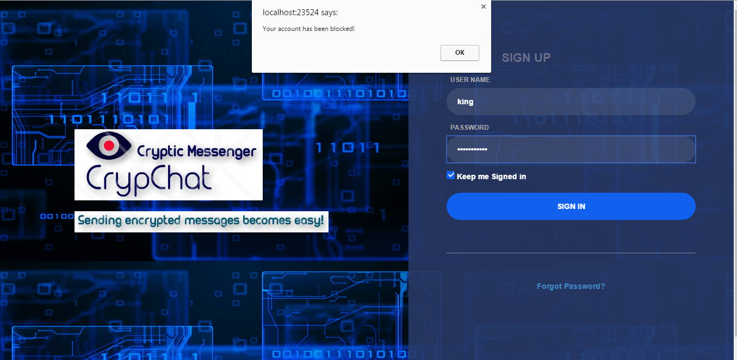

**5.8 Encrypted and Decrypted Message**

**a. Cipher text **

**b. On clicking different bubbles text can get decipher automatically**

**5.9 Option of forget password for user** 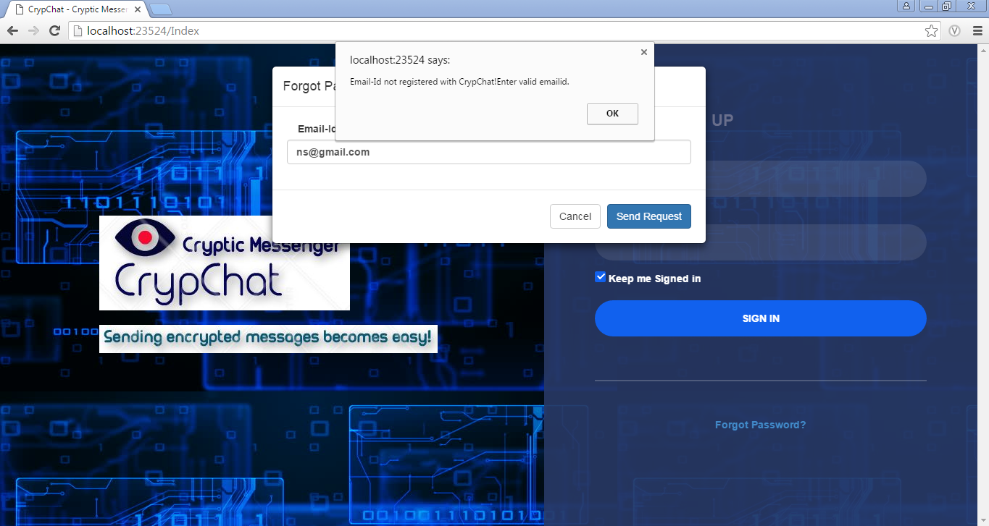

Unit Test Plan

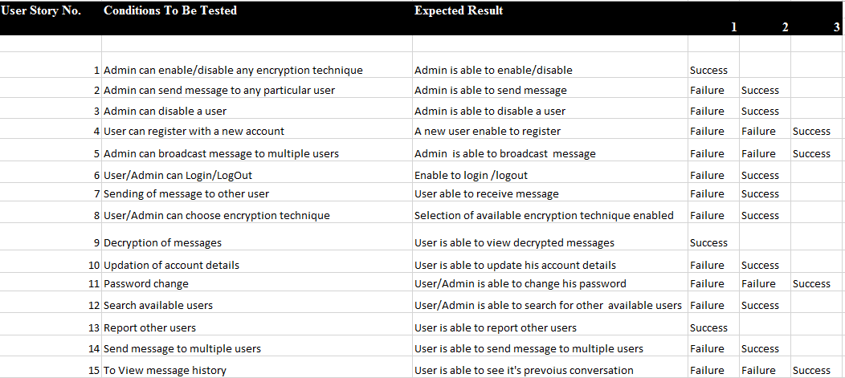

Integration Test Plan

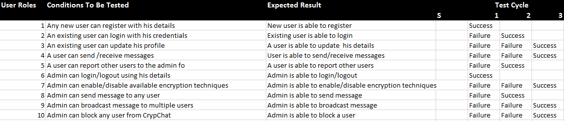

**Chapter-6**

**Findings and Conclusion**

6.1 Conclusion

CrypChat allows users to send messages to other users in an encrypted form so that message can transmit securely from one user to other user. When a user want to send any message, he/she can choose any available encryption technique to encrypt the message.

This web application provides a user friendly interface to the users.

6.2 Future Work

In future, more features like video calling, create groups, create pages etc. can be introduced.

The project can be taken online so that users can interact with each other online.

Also, a mobile app can be developed for the messenger so that it becomes easier for the users to access the chat messenger

**References**

* 1. <https://www.w3schools.com/xml/ajax_intro.asp>
  2. <https://stackoverflow.com/questions/9436534/ajax-tutorial-for-post-and-get>
  3. <https://www.tutorialspoint.com/cryptography/traditional_ciphers.htm>
  4. <https://www.programmingalgorithms.com/algorithm>

**Bio-Data**

|  |  |  |  |
| --- | --- | --- | --- |
| **Student Name** | **Training/Internship** | **Projects Undertaken** | **Skill set** |
| Karan Singla | Infosys – Microsoft developer  TNine Infotech- Web Development | * CrypChat – A Cryptic Messenger * KayCee Pro web app development * Maintenance of tnine.io website * TNine Planning and Control | ASP.NET, Python, C#, JavaScript, Ajax, CSS,HTML5 |